Name:……………………………………………………………..

ID:…………………………………………………………………

**PART 1: LOC**

***Exercise 1:* Estimation for Function A**

Description:

include <stdio.h>  
int main(void) {  
 printf("Hello World");  
 return 0;  
}

How many LOC in this function (Conte)?..................

Conte Đếm nhiêu dòng lấy nhiêu dòng

***Exercise 2:* Estimation for Projects**

|  |  |  |  |  |  |  |  |  |
| --- | --- | --- | --- | --- | --- | --- | --- | --- |
| **Project** | **LOC** | **People** | **Error** | **PP.Doc** | **Time** | **Effort** | **Quality** | **Document** |
| A | 15,000 | 3 | 135 | 356 | 1 month | LOC / (People * Time(m)) | **Error/KLOC** | **PP.Doc/KLOC** |
| B | 28,200 | 5 | 250 | 1232 | 2 month |  |  |  |
| C | 30,000 | 6 | 256 | 980 | 1.5 month |  |  |  |

***Exercise 3:* Estimation for Projects**

Assuming

- Estimated project LOC = MSSV ***(VD: 1800234)***

- Organisational productivity (similar project type) = 620 LOC/p-m

- Burdened labour rate = 5000 $/p-m

Calculate

Effort = LOC / (People * Time(m))

Cost per LOC = Burdened labour rate / Organisational productivity (similar project type)

Project total Cost = Burdened labour rate * Effort

***Exercise 4:* Estimation for Projects**

A system is composed of 7 subsystems as below.

Given for each subsystem the size in LOC and the 2 metrics: productivity LOC/pm (pm: person month), Cost $/LOC.

Calculate the system **total cost** in $ and **effort** in months .



**Total Cost = Tổng cost = Tổng ( estimated LOC * $/LOC) = Làm tròn**

**Effort = (estimated LOC) / (LOC/pm)**

**PART 2: CYCLOMATIC COMPLEXITY**

**Code of Program**

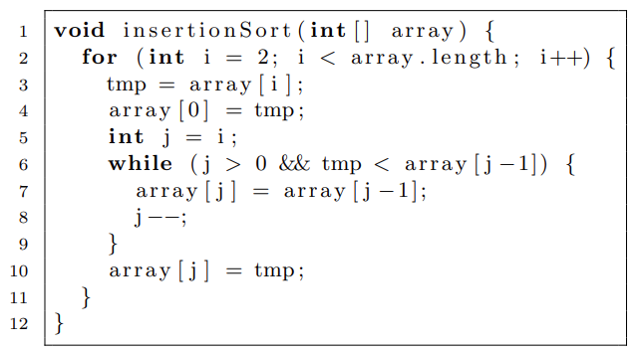

1. Draw Corresponding graph G

2. Calculate Cyclomatic complexity

**PART 3: COCOMO MODEL**

***Exercise 1:* Estimation for Projects**

Suppose a project was estimated to be 400 KLOC. Calculate the **effort** and **development time** for each of the three model i.e., organic, semi-detached & embedded.

|  |  |  |  |  |
| --- | --- | --- | --- | --- |
| Kiểu dự án | a | b | c | d |
| Organic | 2.4 | 1.05 | 2.5 | 0.38 |
| Semi - detached | 3.0 | 1.12 | 2.5 | 0.35 |
| Embeded | 3.6 | 1.2 | 2.5 | 0.32 |

**Effort: E = a × Lb**

**development time: T = D = c × Ed**

***Exercise 2:* Estimation for Projects**

A project size of 200 KLOC is to be developed. Software development team has average experience on similar type of projects. The project schedule is not very tight. Calculate the **Effort**, **development time**, **average staff size**, and **productivity** of the project in semidetached mode.

**average staff size: N = E/T = E/D**

**productivity = KLOC / E = KLOC/PM**

**P = LOC/PM**